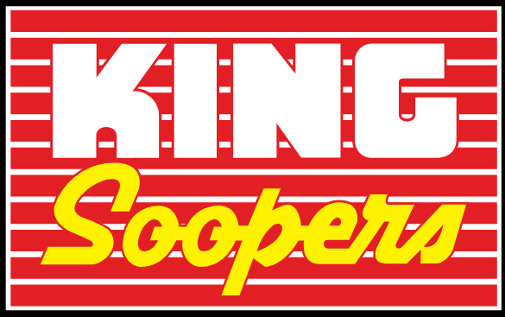
Start Fundraising today for the Washington DC Trip!

Register your Loyalty Card in the Community Rewards Program and raise money for your student.
Enroll Now:
- Log onto: https://www.kingsoopers.com/
- Create an account using your Loyalty Card or Alternate ID
- Click on King Soopers Community Rewards under the Save Tab
- Click on Enroll Now
- Our program is called: Washington DC Scholarship Fund – Hamilton M.S.
- Start to raise funds for your student’s trip

If you have already Enrolled in the
Community Rewards Program:
Log in to your account, follow the directions above to see your earnings for the 2nd quarter of 2019.
Please let us know your earnings.
We need to know your earnings to apply the amount to your student’s scholarship account!
Information Needed for Scholarship Fund

Student’s Name: ______________________________
Student’s ID: __________________________________ (Lunch Number)
Parent’s Name: ________________________________
Parent’s Contact: ______________________________ (Email or Phone)

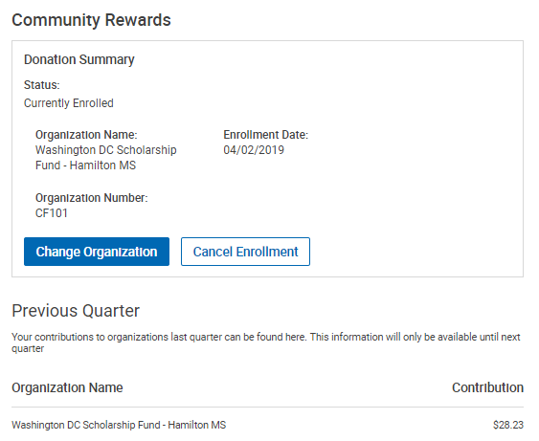

A screenshot with the above information can be sent to: leannegolledge@gmail.com
at the end of each quarter!
April; July; October; January

